**School of Computer Science Engineering and Technology**

Course- BTech Type- Elective

Course Code- CSET335L Course Name-Deep Learning

Year- 2023 Semester- Even

**Lab Assignment 4 – Optimization**

We have gone through various ways to optimize and improve our deep learning model. Now it’s time to experiment’s and check empirically whether those methods are useful or not. For that let’s do your experiment in the following manner and make a learning curve every time to see the impact.

1. 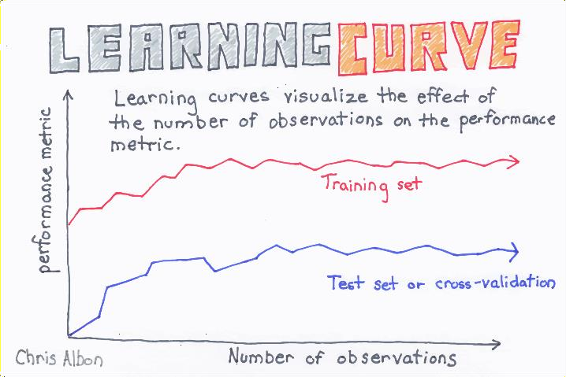Impact of optimizers
   1. With only gradient descent
   2. AdaGrad
   3. RMSprop
   4. ADAM
   5. AdaDelta
   6. SGD

For every variation, you must plot the learning curve for any five of the following datasets:

|  |  |
| --- | --- |
| **Dataset No** | **Dataset** |
| 1 | oxford_flowers102 |
| 2 | Fashion mnist |
| 3 | cars196 |
| 4 | Cifar100 |
| 5 | Yes_no (Any Dataset) |
| 6 | Cifar10 |
| 7 | Fashion mnist |
| 8 | caltech_birds2011 |
| 9 | EMNIST |
| 10 | Cifar10 |

NOTE: During the lab, you must show the results on 2 datasets.

Write a note (200 words) on which method is best.

Final submission to be done at LMS.